Supplementary Information
Benchmarking methods and data for the whole-outline geometric morphometric analysis of lithic tools
Renata Pedroso de Araujo¹, Felix Riede², Mercedes Okumura³, Astolfo G. M. Araujo¹, Alice Leplongeon⁴, Colin Wren⁵, José Ramón Rabuñal^{2,6}, Marcelo Cardillo⁷, María Barrera Cruz⁸, David N. Matzig^{2*}

¹ Museum of Archaeology and Ethnology, University of São Paulo, São Paulo, Brazil.
² Department of Archaeology and Heritage Studies, Aarhus University, Aarhus, Denmark.
³ Department of Genetics and Evolutionary Biology, Biosciences Institute, University of São Paulo, São Paulo, Brazil.
⁴ Centre for Archaeological Research of Landscapes, KU Leuven, Belgium & UMR Histoire naturelle de l'Homme préhistorique (HNHP), Muséum national d'Histoire naturelle - CNRS - UPVD, Paris, France.
⁵ Department of Anthropology, University of Colorado Colorado Springs, Colorado, USA.
⁶ Instituto Universitario de Investigación en Arqueología y Patrimonio Histórico (INAPH), University of Alicante, Alicante, Spain.
⁷ Consejo de Investigaciones Científicas y Técnicas (CONICET) - Instituto Multidisciplinario de Historia y Cs. Humanas (IMHICIHU) - Facultad de Filosofía y Letras de la Universidad de Buenos Aires (FFyL-UBA ), Buenos Aires, Argentina.
⁸ Departament de Prehistòria, Arqueologia i Història Antiga, Universitat de València, València, Spain.

*corresponding author: david.matzig@cas.au.dk (https://orcid.org/0000-0001-7349-5401)

Introduction
This document provides further details for the data set published along with the article “Benchmarking methods and data for the whole-outline geometric morphometric analysis of lithic tools” by Araujo et al. The data is available on Zenodo (https://doi.org/10.5281/zenodo.7757171).

Metadata spreadsheet
Supplementary table 1: Description of all columns/variables of the metadata spreadsheet provided in comma separated values (csv) format in the supplementary data, as well as metadata included in the outlines. NAs mark cells in which no data was available.

Variable | Description
image_ID | This column contains the names of the images, from which the single artefacts have been extracted.
artefact_ID | This column contains an individual artefact identifier necessary for the combination of metadata and outlines. artefact_ID and consists of the image_ID combined with an individual number for each individual artefact that has been extracted from that image using the outlineR R package (Matzig 2021a).
artefact_type | A specification of the artefact type as identified by the expert editors.
archaeological_culture_name | A specification to which archaeological culture the artefact belongs, as provided by the expert editors.
site_name | Name of the site, from which the artefact is from.
level_layer_concentration
country | Name of the country, from which the artefact is from.
latitude_y | Latitude coordinates of the sites in WGS84.
longitude_x | Longitude coordinates of the sites in WGS84.
archaeological_period | Archaeological period to which the artefact has been attributed to.
dating_BP | (Uncalibrated) date before present (BP).
dating_sd_BP | Standard deviation for uncalibrated date BP.
dating_labcode | Lab-Code for 14C-date.
dating_method | Specification of dating method.
citation_reference | Reference indicating where the images of the outlines have been taken from. The full references are listed below. If no reference is provided, the data has been published here by the expert editor for the first time.
editor_name | Name of the expert editor who submitted the data.
description | The experts’ short description of the submitted data sets.

Outline data
There are 646 outlines contained in this data set. They have been extracted by the expert editors from legacy data and photographs using the R-package outlineR (Matzig 2021a) in combination with the protocol described in Matzig (2021b). Due to copyright issues, we do not publish the raw images but only the processed outline data. The outlines are stored in RDS format, which can be opened in the programming language R (R Core Team 2022). There, they – together with their associated metadata – are retained in Out-format specific to the Momocs R-package developed by Bonhomme et al. (2014). All outlines have been centred and scaled.
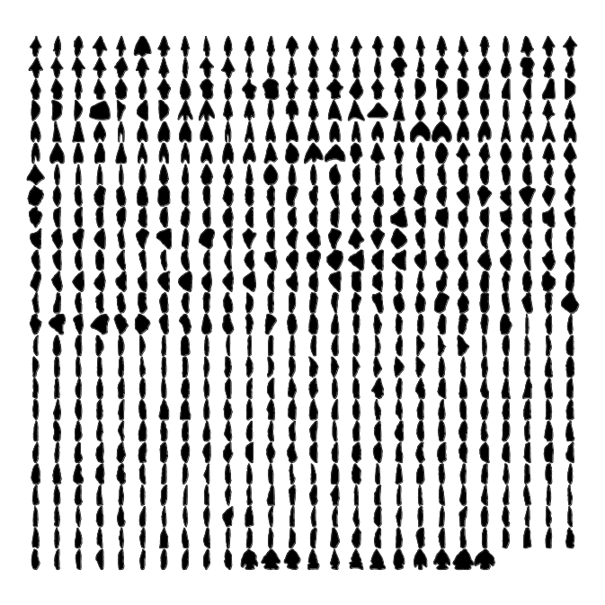
Supplementary figure 1: All outlines contained in the data set visualised in a single panel using the Momocs package (Bonhomme et al. 2014).

R code
The R code provides an example on how to load, inspect, and plot different aspects of the data. It requires the following R-packages: dplyr (>= 1.0.8), ggplot2 (>= 3.4.0), ggthemes (>= 4.2.4), magrittr (>= 2.0.2), Momocs (>= 1.3.0), outlineR (>= 0.1.0), raster (>= 3.5-15), readr (>= 2.1.2), remotes (>= 2.4.2), rgeos (>= 0.5-9), rworldmap (>= 1.3-6), sp (>= 1.4-6).

References
Araujo, A .G. M., Feathers, J. K., Hartmann, G. A., Ladeira, F. S. B., Valezio, E. V., Nascimento, D. L., Ricci, O., Marum, V. J. O., & Trindade, R. I. F. (2022). Revisiting Alice Boer: Site formation processes and dating issues of a supposedly pre‐Clovis site in Southeastern Brazil. Geoarchaeology, 37(1), 32–58. https://doi.org/10.1002/gea.21831

Baales, M. (2002). Der spätpaläolithische Fundplatz Kettig: Untersuchungen zur Siedlungsarchäologie der Federmesser-Gruppen am Mittelrhein. Verlag Rudolf Habelt GmbH.

Benecke, N., Bollogino, R., Küßner, M., & Weber, C. (2006). Zur Datierung und Fauna des spätglazialen Schichtkomplexes am Abri Fuchskirche I bei Allendorf, Lkr. Saalfeld-Rudolstadt. Alt-Thüringen, 39, 121–130.

Bolus, M. (1992). Die Siedlungsbefunde des späteiszeitlichen Fundplatzes Niederbieber (Stadt Neuwied): Ausgrabungen 1981-1988; mit Beiträgen von Gabriele Roth, Siegfried Stephan, Rolf C. Rottländ. Rudolf Habelt GmbH.

Bonhomme, V., Picq, S., Gaucherel, C., & Claude, J. (2014). Momocs: Outline Analysis Using R. Journal of Statistical Software, 56(13). https://doi.org/10.18637/jss.v056.i13
Cardillo, M., & Muscio, H.J. (2021). Filogenia, innovación y recambio tecnológico en las puntas de proyectil del Holoceno medio de las Tierras Altas Surandinas. Mundo de Antes, vol. 2 (pp.13–38).
Close, A.E. (1989). Report on Site E-78-3: A deeply stratified sequence of early Kubbaniyan occupations. In F. Wendorf, R. Schild, & A. E. Close (Eds.), The prehistory of Wadi Kubbaniya, vol. 3 (pp. 375–469). SMU Press.

Close, Angela E. (1989a). Report on Site E-81-1: An Early Kubbaniyan Site on the Edge of the Kubbaniyan Dune Field. In F. Wendorf, R. Schild, & A. E. Close (Eds.), The prehistory of Wadi Kubbaniya, vol. 3 (pp. 490–523). SMU Press.

Close, Angela E. (1989b). Report on Site E-83-4: A small Afian surface concentration in the Kubbaniya Dune Field. In F. Wendorf, R. Schild, & A. E. Close (Eds.), The prehistory of Wadi Kubbaniya, vol. 3 (pp. 697–704). SMU Press.

Close, Angela E., Wendorf, F., & Schild, R. (1979). The Afian: a study of stylistic variation in a Nilotic industry. Department of Anthropology, SMU Press.

De Bie, M., & Caspar, J.-P. (2000). Rekem. A Federmesser Camp on the Meuse River Bank. Leuven University Press.

Fiedler, L. (1994). Alt- und mittelsteinzeitliche Funde in Hessen. Theiss.

Fruth, H.-J. (1979). Ein spätpaläolithischer Fundplatz bei Mühlheim-Dietesheim, Kreis Offenbach. Archäologisches Korrespondenzblatt, 9, 261–266.

Hofbauer, H. (1992). Ein spätpaläolithischer Fundplatz bei Rothenkirchen, Kreis Fulda (Hessen). Archäologisches Korrespondenzblatt, 22, 329–340.
Hornauer-Jahnke, T., & Noack, E. (2019). Der Übergang vom Jung- zum Spätpaläolithikum in Südwestdeutschland: Der Zigeunerfels. In M. Baales & C. Pasda (Eds.), “All der holden Hügel ist keiner mir fremd ...”: Festschrift zum 65. Geburtstag von Claus-Joachim Kind (pp. 315–336). Verlag Dr. Rudolf Habelt.

Koole, E. K. M. (2007). Pré-história da Província Cárstica do Alto São Francisco, Minas Gerais: a indústria lítica dos caçadores-coletores arcaicos [Master’s thesis]. University of São Paulo.

Loew, S. (2005). Der Federmesser-Fundplatz Rüsselsheim 122 am unteren Main (Hessen). Archäologisches Korrespondenzblatt, 35, 143–158.

Matzig, D. N. (2021a). OutlineR: An R package to derive outline shapes from (multiple) artefacts on JPEG images (0.1.0). Zenodo. https://doi.org/10.5281/ZENODO.4527469

Matzig, D. N. (2021b). outlineR: Artefact Processing and Extraction Protocol v1 [Preprint]. https://doi.org/10.17504/protocols.io.bygaptse
Muscio, H.J., & Cardillo, M. (2019). Filogenias andinas: análisis cladístico de las puntas líticas del Holoceno medio de la Puna de Argentina y el norte de Chile. Relaciones de la Sociedad Argentina de Antropología , vol. 2 ( pp. 213–232).
Oms, F. X., Morales, J. I., Cebrià, A., Mestres, J., & Fullola, J. M. (2019). Nuevas intervenciones en la Cova Gran y la Cova Freda de Montserrat (Collbató, Barcelona) casi 100 años después. Trabajos De Prehistoria, 76(2), 335–344. https://doi.org/10.3989/tp.2019.12241

R Core Team. (2022). R: A Language and Environment for Statistical Computing. R Foundation for Statistical Computing. https://www.R-project.org/

Richter, J. (2012). Rietberg und Salzkotten-Thüle – Anfang und Ende der Federmessergruppen in Westfalen. Verlag Marie Leidorf.

Rabuñal, J. R. (2016). La tecnología lítica del Magdaleniense Superior Final de la Cova de Les Borres (La Febró): estudio morfotécnico y definición de estrategias de explotación [Master’s thesis, Universitat Rovira i Virgili].

Schwabedissen, H. (1954). Die Federmessergruppen des nordwesteuropäischen Flachlandes. Zur Ausbreitung des Spät-Magdalénien. Karl Wachholtz Verlag GmbH.

Vollbrecht, J. (2005). Spätpaläolithische Besiedlungsspuren aus Reichwalde, Reichwalde 1. Landesamtes für Archäologie Sachsen.

Winkler, K. (2010). Der spätpaläolithische Fundplatz Golßen, Lkr. Dahme-Spreewald. Analyse der Steinartefakte und Befunde der Grabung von 1968. Veröffentlichungen Zur Brandenburgischen Landesarchäologie, 41/42, 7–93.

